# AWS DAILY TASKS

1. Launch one EC2 using Amazon Linux 2 image and add a script in user data to install Apache.

* Launch a ec2 instance with a pem key and ur public ip.
* Then check the security inbound rules ssh should b 22 nd http in 80
* Then go to the bottom instance and additional info open it
* And use a bash script for it
* Then go the git bash connect to the server nd take the public ip and paste it with last gave that port number of :80
* Here the results are

**Bash script download apache process:**

#!/bin/bash

# Update system

yum update -y

# Install Apache (httpd)

yum install -y httpd

# Enable Apache to start on boot

systemctl enable httpd

# Start Apache service

systemctl start httpd

# Create a test index.html

echo "<h1>Welcome to Apache on Amazon Linux 2!</h1>" > /var/www/html/index.html

**Note:** Using # it means gave a comment it will gave uh a message who ever check it that one he will understand easily.

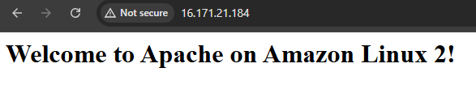

1. Launch one EC2 using Ubuntu image and add a script in user data to install nginx ?

* Launch a ec2 instance with a pem key and ur public ip.
* Then check the security inbound rules ssh should b 22 nd http in 80
* Then go to the bottom instance and additional info open it
* And use a bash script for it nginx
* Then go the git bash connect to the server nd take the public ip and paste it with last gave that port number of :80
* Here the results are

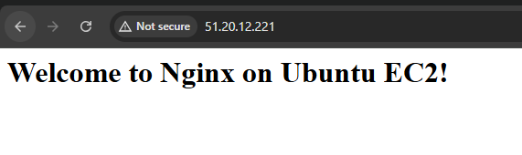

**Bash script for nginx:**

#!/bin/bash

# Update system packages

apt-get update -y

# Install Nginx

apt-get install -y nginx

# Enable Nginx to start on boot

systemctl enable nginx

# Start Nginx service

systemctl start nginx

# Create a custom index page

echo "<h1>Welcome to Nginx on Ubuntu EC2!</h1>" > /var/www/html/index.nginx-debian.html

Note: # uses for only gave a comments just want to know the actual purpose what we are doing in bash scripting.

1. Launch one Windows server and install Tomcat on Windows.

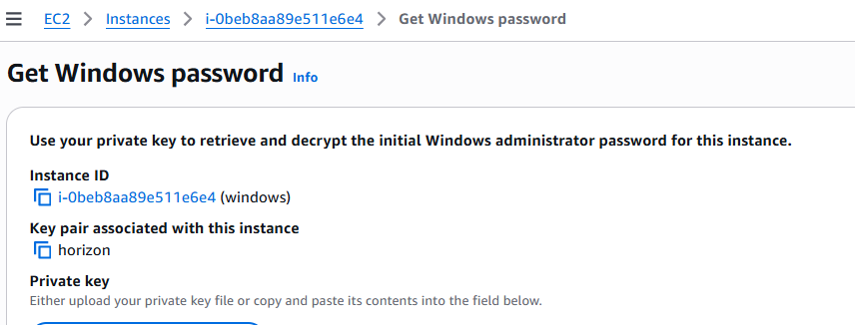

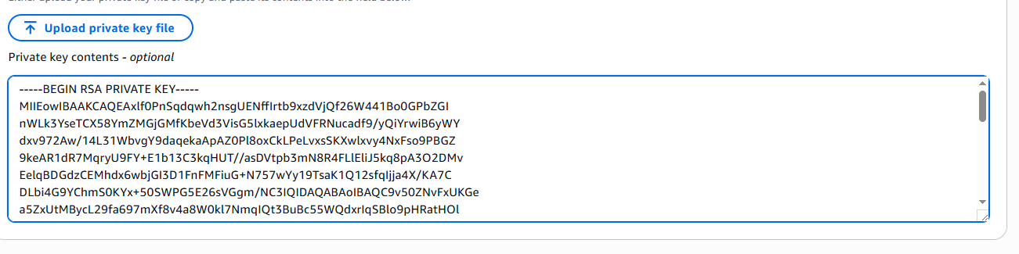



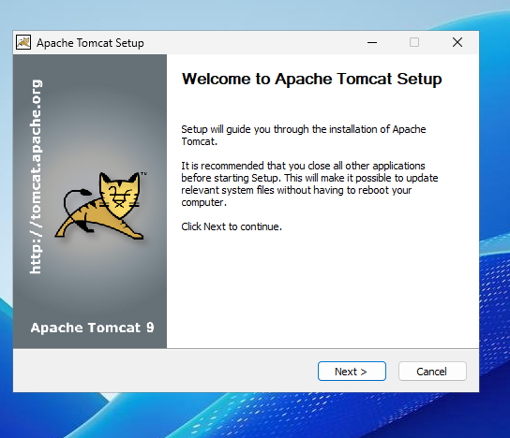

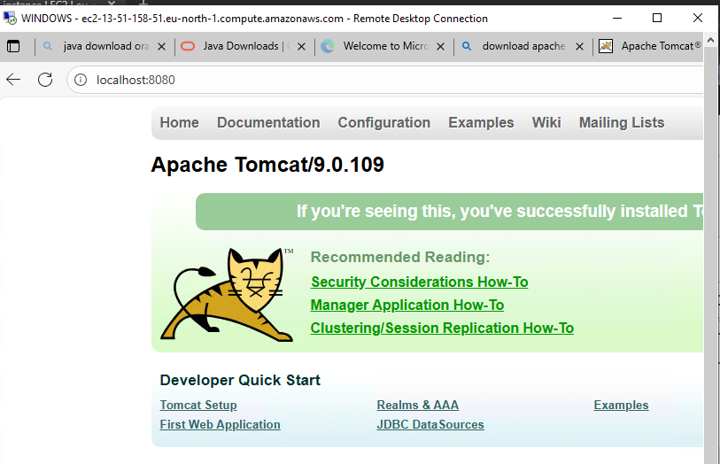

Change port number in 8081 in again install a apache tomcat nd service name change and port number is 8081 so here the result:

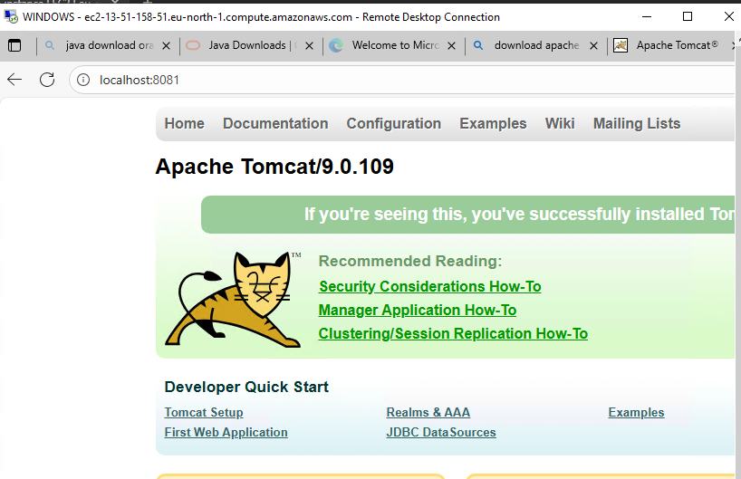

1. Take a snapshot of the instance created in Task 1.

· Go to **EC2 Dashboard → Instances**.

· Select the instance you created in nginx webcheck

· Scroll down to **Storage** → find the **Volume ID** (attached root volume).

· Click the **Volume ID** → you’ll be redirected to the **EBS Volumes** page.

·  **Create Snapshot**. Nd select the instance which one uh want here the results are..

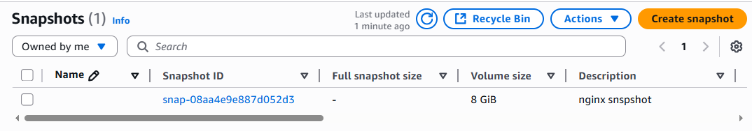

1. Assign passwordless authentication for the EC2 created in Task 2.

* to create passwordless authentication:  
  create a ssh-key in our local machine---ssh-keygen  
  then copy your public key using---cat /c/Users/DELL/.ssh/id_rsa.pub  
    
  create an user ---useradd techie  
  password for user---passwd techie  
  ssh-keygen---create a ssh key in ec2 machine   
  vi /root/.ssh/id_rsa.pub (paste your local machine key here by keeping   
  present key as same...  
  vi /etc/ssh/sshd_config----enable password authentication as yes  
  systemctl restart sshd---restart your sshd   
  now connect on your local machine:  
  ssh techie@public-ip  
  allow fingerprint authnetication:yes  
  enter password  
  hence you will be able to connect your instance

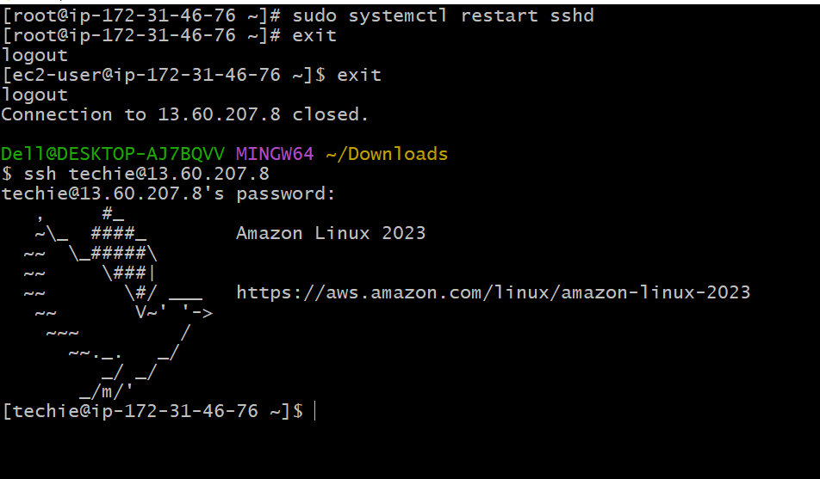

1. Launch any EC2 using the spot purchasing option.

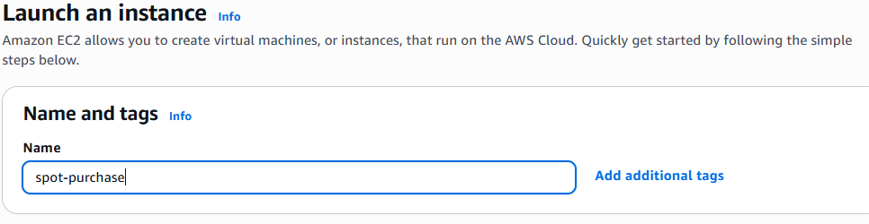

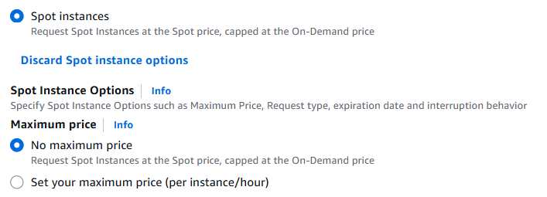

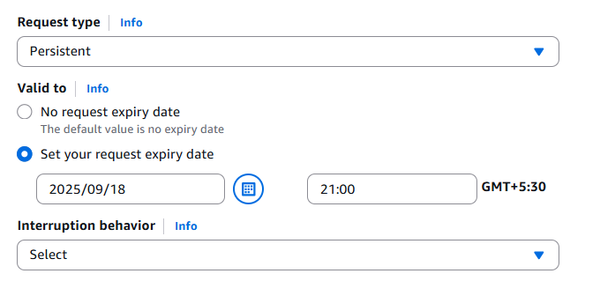

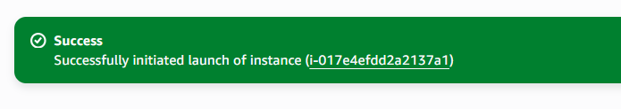

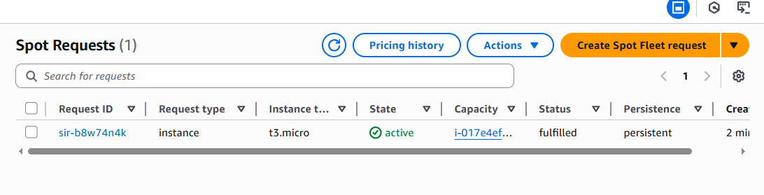

1. Enable termination policy on the EC2 created in Task 2.

· Go to the **EC2 Dashboard** in AWS Console.

· Select the **EC2 instance** you created in Task 2.

· In the **Instance settings** menu, click **Change termination protection**.

· Select **Enable** and save.

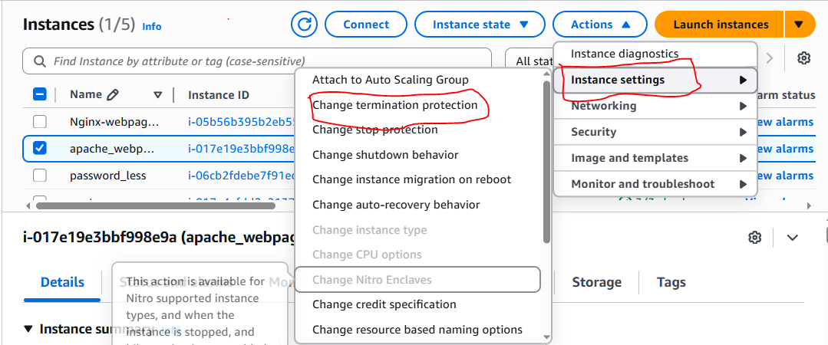

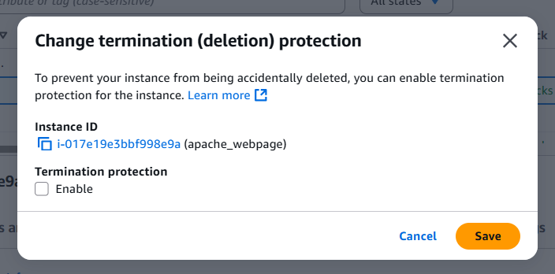

1. Launch one EC2 using AWS CLI.

* Launch instance name with aws
* And connect to the server then
* Wget **downlaod cli https://awscli.amazonaws.com/AWSCLIV2.msi**
* Then gave a command of aws configure it will show uh a options like
* Access key
* Secreat access key
* Region and format
* For accesskey and secreat key open our profile then security credentiols and it will genarate the keys
* Then aws ec2 describe-instances.
* Here the results.

